# SMA-Based Signal Strategy with Backtest

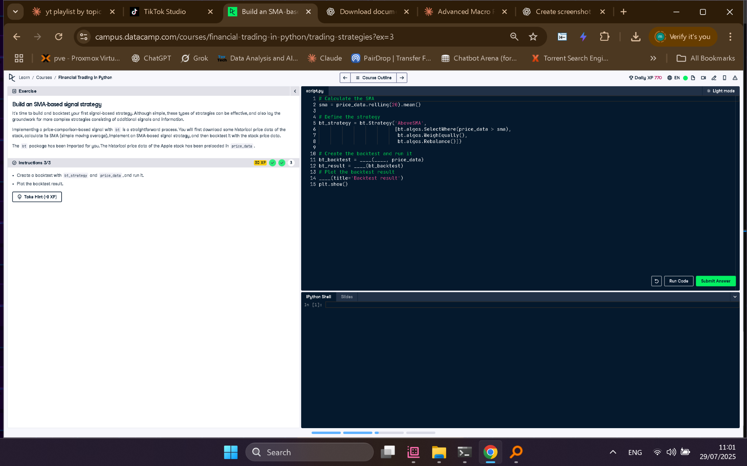

## Full Python Answer

# Calculate the SMA  
sma = price_data.rolling(20).mean()  
  
# Define the strategy  
bt_strategy = bt.Strategy('AboveSMA',  
 [  
 bt.algos.SelectWhere(price_data > sma),  
 bt.algos.WeighEqually(),  
 bt.algos.Rebalance()  
 ])  
  
# Create the backtest and run it  
bt_backtest = bt.Backtest(bt_strategy, price_data)  
bt_result = bt.run(bt_backtest)  
  
# Plot the backtest result  
bt_result.plot(title='Backtest result')  
plt.show()

## Explanation in Simple Words

This script builds a trading strategy using a 20-day moving average. If the current price is above the average, the strategy invests. The backtest runs this rule on historical Apple stock data and visualizes the returns. It helps check how profitable the strategy would have been.